Plate Tectonics

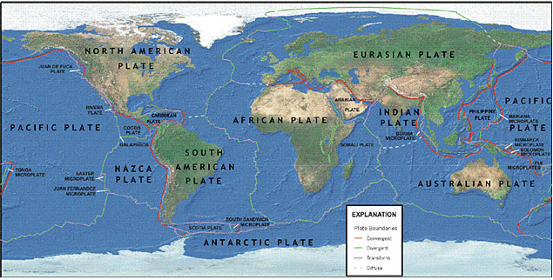

Earth's outer shell, the lithosphere, long thought to be a continuous, unbroken, crust is actually a fluid mosaic of many irregular rigid segments, or plates. Comprised primarily of cool, solid rock 4 to 40 miles thick,* these enormous blocks of Earth’s crust vary in size and shape, and have definite borders that cut through continents and oceans alike. *[Oceanic crust is much thinner and more dense than continental, or terrestrial crust]. There are nine large plates and a number of smaller plates. While most plates are comprised of both continental and oceanic crust the giant Pacific Plate is almost entirely oceanic, and the tiny Turkish-Aegean Plate is entirely land. Of the nine major plates, six are named for the continents embedded in them: the North American, South American, Eurasian, African, Indo-Australian, and Antarctic. The other three are oceanic plates: the Pacific, Nazca, and Cocos.

The relative small size of the numerous other plates neither diminishes their significance, nor their impact on the surface activity of the planet. The jostling of the tiny Juan de Fuca Plate, for example, sandwiched between the Pacific and North American Plate near the state of Washington, is largely responsible for the frequent tremors and periodic volcanic eruptions in that region of the country.

How Plates Move
Powered by forces originating in Earth’s radioactive, solid iron inner core, these tectonic plates move ponderously about at varying speeds and in different directions atop a layer of much hotter, softer, more malleable rock called the athenosphere. Because of the high temperatures and immense pressures found here, the uppermost part of the athenosphere is deformed and flows almost plastically just beneath the Earth’s surface. This characteristic of the athenosphere to flow allows the plates to inch along on their endless journeys around the surface of the earth, moving no faster than human fingernails grow
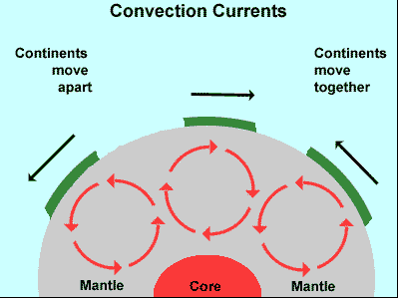

idea that might explain the ability of the athenosphere to flow is the idea of convection currents. When mantle rocks near the radioactive core are heated, they become less dense than the cooler, upper mantle rocks. These warmer rocks rise while the cooler rocks sink, creating slow, vertical currents within the mantle (these convection currents move mantle rocks only a few centimeters a year). This movement of warmer and cooler mantle rocks, in turn, creates pockets of circulation within the mantle called convection cells. The circulation of these convection cells could very well be the driving force behind the movement of tectonic plates over the asthenosphere.

Plate Boundaries
There are 3 primary types of Tectonic Plate boundaries: Divergent boundaries; Covergent
boundaries; and Transform boundaries. As the giant plates move, diverging [pulling apart] or
converging [coming together] along their borders, tremendous energies are unleashed
resulting in tremors that transform Earth’s surface. While all the plates appear to be
moving at different relative speeds and independently of each other, the whole jigsaw
puzzle of plates is interconnected. No single plate can move without affecting others,
and the activity of one can influence another thousands of miles away. For example,
as the Atlantic Ocean grows wider with the spreading of the African Plate away from
the South American Plate, the Pacific sea floor is being consumed in deep subduction
trenches over ten thousand miles away.
(All graphics courtesy of USGS.org).

Divergent Boundaries: At divergent boundaries new crust is created as wo or more plates pull away from each other. Oceans are born and grow wider where plates diverge or pull apart. As seen below, when a diverging boundary occurs on land a 'rift', or separation will arise and over time that mass of land will break apart into distinct land masses and the surrounding water will fill the space between them.

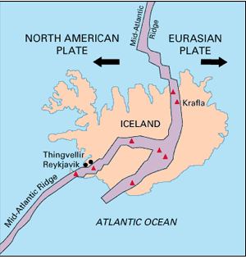
Iceland offers scientists a natural laboratory for studying - on land - the processes that occur along submerged parts of a divergent boundary. Iceland is splitting along the Mid-Atlantic Ridge - a divergent boundary between the North American and Eurasian Plates. As North America moves westward and Eurasia eastward, new crust is created on both sides of the diverging boundary. While the creation of new crust adds mass to Iceland on both sides of the boundary, it also creates a rift along the boundary. Iceland will inevitably break apart into two separate landmasses at some point in the future, as the Atlantic waters eventually rush in to fill the widening and deepening space between.

Convergent Boundaries: Here crust is destroyed and recycled back into the interior of the Earth as one plate dives under another. These are known as Subduction Zones - mountains and volcanoes are often found where plates converge. There are 3 types of convergent boundaries: Oceanic-Continental Convergence; Oceanic-Oceanic Convergence; and Continental-Continental Convergence.

Oceanic-Continental Convergence
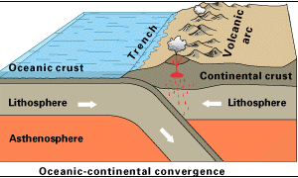
When an oceanic plate pushes into and subducts under a continental plate, the overriding continental plate is lifted up and a mountain range is created. Even though the oceanic plate as a whole sinks smoothly and continuously into the subduction trench, the deepest part of the subducting plate breaks into smaller pieces. These smaller pieces become locked in place for long periods of time before moving suddenly and generating large earthquakes. Such earthquakes are often accompanied by uplift of the land by as much as a few meters.

Oceanic-Oceanic Convergence

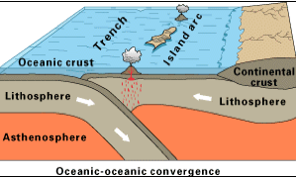
When two oceanic plates converge one is usually subducted under the other and in the process a deep oceanic trench is formed. The Marianas Trench, for example, is a deep trench created as the result of the Phillipine Plate subducting under the Pacific Plate.

Oceanic-oceanic plate convergence also results in the formation of undersea volcanoes. Over millions of years, however, the erupted lava and volcanic debris pile up on the ocean floor until a submarine volcano rises above sea level to form an island volcano. Such volcanoes are typically strung out in chains called island arcs.

Continental-Continental Convergence

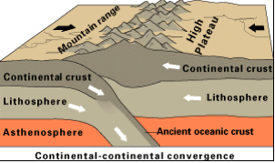
When two continents meet head-on, neither is subducted because the continental rocks are relatively light and, like two colliding icebergs, resist downward motion. Instead, the crust tends to buckle and be pushed upward or sideways. The collision of India into Asia 50 million years ago caused the Eurasian Plate to crumple up and override the Indian Plate. After the collision, the slow continuous convergence of the two plates over millions of years pushed up the Himalayas and the Tibetan Plateau to their present heights. Most of this growth occurred during the past 10 million years.

Transform-Fault Boundaries: Transform-Fault Boundaries are where two plates are sliding horizontally past one another. These are also known as transform boundaries or more commonly as faults.

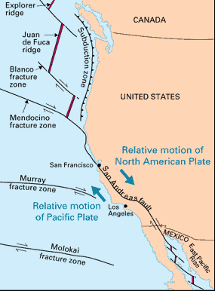
Most transform faults are found on the ocean floor. They commonly offset active spreading ridges, producing zig-zag plate margins, and are generally defined by shallow earthquakes. A few, however, occur on land. The San Andreas fault zone in California is a transform fault that connects the East Pacific Rise, a divergent boundary to the south, with the South Gorda -- Juan de Fuca -- Explorer Ridge, another divergent boundary to the north. The San Andreas is one of the few transform faults exposed on land. The San Andreas fault zone, which is about 1,300 km long and in places tens of kilometers wide, slices through two thirds of the length of California. Along it, the Pacific Plate has been grinding horizontally past the North American Plate for 10 million years, at an average rate of about 5 cm/yr. Land on the west side of the fault zone (on the Pacific Plate) is moving in a northwesterly direction relative to the land on the east side of the fault zone (on the North American Plate).

Information from platetectonics.com

